**Assignment 18.3**

You take the SAT and score 1100. The mean score for the SAT is 1026 and the standard

deviation is 209. How well did you score on the test compared to the average test taker?

Step 1: X-value into the z-score equation. X-value is SAT score, 1100.  
[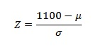](http://www.statisticshowto.com/wp-content/uploads/2013/08/CALCULATE-A-Z-SCORE-1.jpg)

* [Navigation](http://www.statisticshowto.com)

Step 2: Put the mean, μ, into the z-score equation.  
[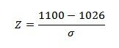](http://www.statisticshowto.com/wp-content/uploads/2013/08/CALCULATE-A-Z-SCORE-2.jpg)

Step 3: Write the standard deviation, σ into the z-score equation.  
[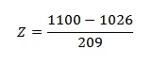](http://www.statisticshowto.com/wp-content/uploads/2013/08/CALCULATE-A-Z-SCORE-3.jpg)

Step 4: (1100 – 1026) / 209 = .354. This means that score was .354 std devs above the mean.

Step 5: Look up your z-value in the z-table to see what percentage of test-takers scored below you.

z-score of .354 is .1368 + .5000* = .6368 or **63.68%**